|  |  |  |  |
| --- | --- | --- | --- |
| **Übungsprotokoll**  **INSY - Informationssysteme** | | | |
|  | **Übungsdatum:**  KW 40/2021 –  KW 41/2021 | **Klasse:**  3AHIT | **Name:**  Felix Schneider |
| **Abgabedatum:**  11.10.2021 | **Gruppe:**  INSY_2 | **Note:** |
| **Leitung:**  DI (FH) Alexander MESTL | **Mitübende:**  - | | |
| **Übungsbezeichnung**:  MySQL Radwerkstatt + Süßigkeitenfabrik - Modell | | | |

**Inhaltsverzeichnis:**

1 Aufgabenstellung 3

2 Theoretische Grundlagen 4

3 Ergebnisse 5

4 Code 6

4.1 Radwerkstatt 6

4.2 Süßigkeitenfabrik 9

5 Kommentar 13

# Aufgabenstellung

Ein Bild, das Text enthält.

Ein Bild, das Text enthält.

# Theoretische Grundlagen

* siehe Datenmodellierung Informationssysteme – Dipl.-Ing. Msc. Paul Panhofer BSc.

# Ergebnisse

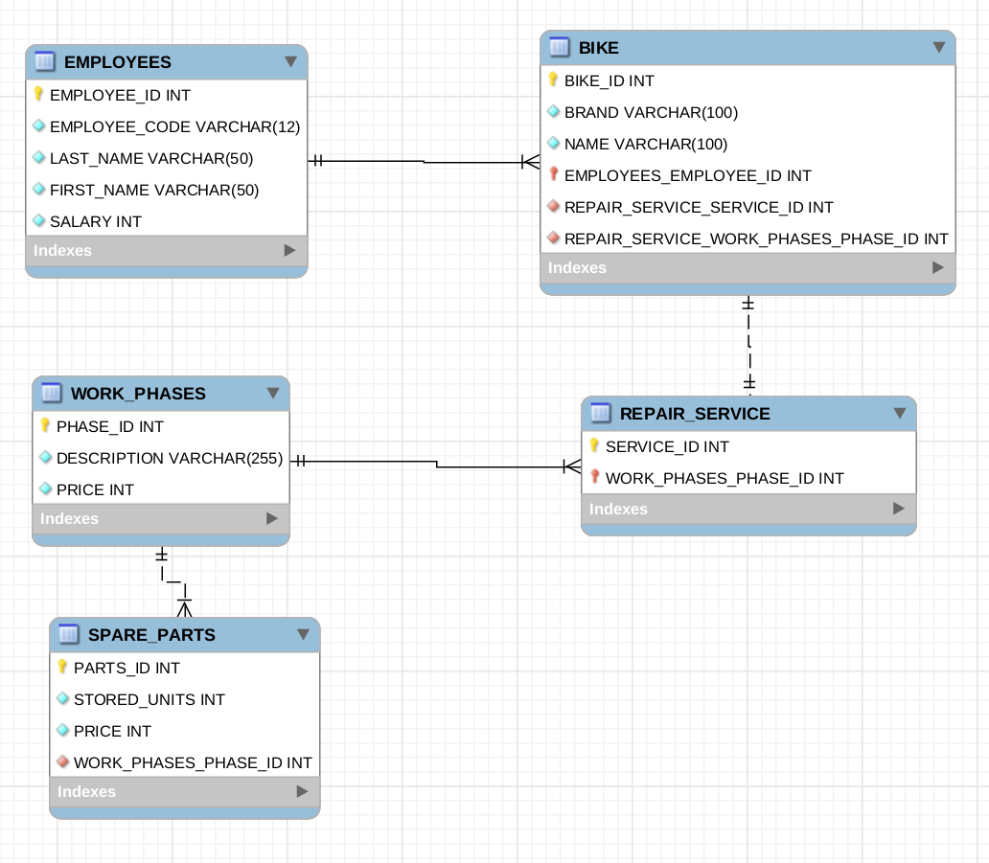

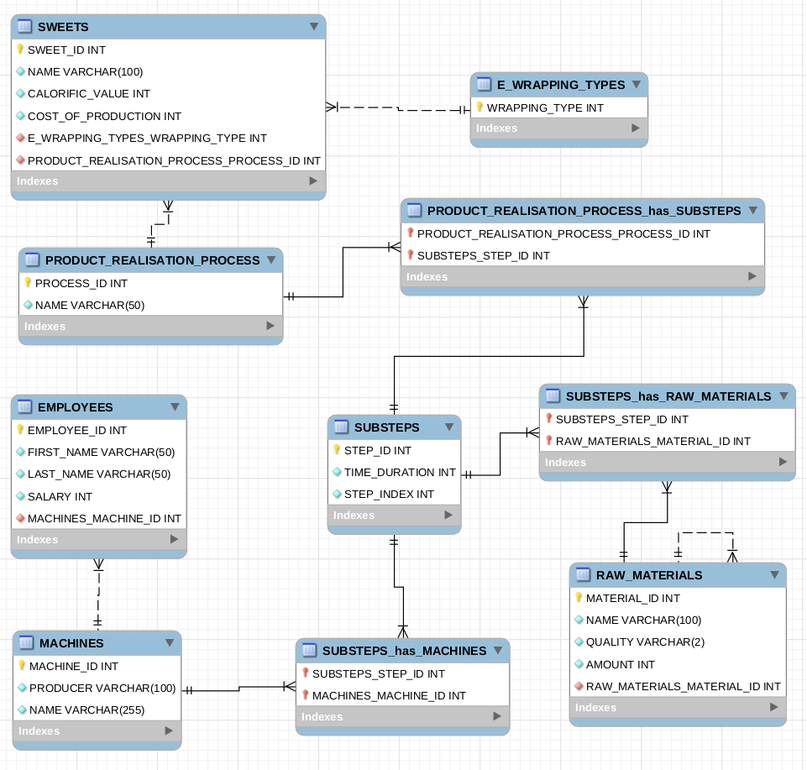

# Code

## Radwerkstatt

-- MySQL Script generated by MySQL Workbench

-- Mo 11 Okt 2021 18:29:42 CEST

-- Model: New Model    Version: 1.0

-- MySQL Workbench Forward Engineering

SET @OLD_UNIQUE_CHECKS=@@UNIQUE_CHECKS, UNIQUE_CHECKS=0;

SET @OLD_FOREIGN_KEY_CHECKS=@@FOREIGN_KEY_CHECKS, FOREIGN_KEY_CHECKS=0;

SET @OLD_SQL_MODE=@@SQL_MODE, SQL_MODE='ONLY_FULL_GROUP_BY,STRICT_TRANS_TABLES,NO_ZERO_IN_DATE,NO_ZERO_DATE,ERROR_FOR_DIVISION_BY_ZERO,NO_ENGINE_SUBSTITUTION';

-- -----------------------------------------------------

-- Schema mydb

-- -----------------------------------------------------

-- -----------------------------------------------------

-- Schema mydb

-- -----------------------------------------------------

CREATE SCHEMA IF NOT EXISTS `mydb` DEFAULT CHARACTER SET utf8 ;

USE `mydb` ;

-- -----------------------------------------------------

-- Table `mydb`.`EMPLOYEES`

-- -----------------------------------------------------

CREATE TABLE IF NOT EXISTS `mydb`.`EMPLOYEES` (

  `EMPLOYEE_ID` INT NOT NULL,

  `EMPLOYEE_CODE` VARCHAR(12) NOT NULL,

  `LAST_NAME` VARCHAR(50) NOT NULL,

  `FIRST_NAME` VARCHAR(50) NOT NULL,

  `SALARY` INT NOT NULL,

  PRIMARY KEY (`EMPLOYEE_ID`),

  UNIQUE INDEX `EMPLOYEE_ID_UNIQUE` (`EMPLOYEE_ID` ASC) VISIBLE,

  UNIQUE INDEX `EMPLOYEE_CODE_UNIQUE` (`EMPLOYEE_CODE` ASC) VISIBLE)

ENGINE = InnoDB;

-- -----------------------------------------------------

-- Table `mydb`.`WORK_PHASES`

-- -----------------------------------------------------

CREATE TABLE IF NOT EXISTS `mydb`.`WORK_PHASES` (

  `PHASE_ID` INT NOT NULL,

  `DESCRIPTION` VARCHAR(255) NOT NULL,

  `PRICE` INT NOT NULL,

  PRIMARY KEY (`PHASE_ID`),

  UNIQUE INDEX `PHASE_ID_UNIQUE` (`PHASE_ID` ASC) VISIBLE)

ENGINE = InnoDB;

-- -----------------------------------------------------

-- Table `mydb`.`REPAIR_SERVICE`

-- -----------------------------------------------------

CREATE TABLE IF NOT EXISTS `mydb`.`REPAIR_SERVICE` (

  `SERVICE_ID` INT NOT NULL,

  `WORK_PHASES_PHASE_ID` INT NOT NULL,

  PRIMARY KEY (`SERVICE_ID`, `WORK_PHASES_PHASE_ID`),

  UNIQUE INDEX `SERVICE_ID_UNIQUE` (`SERVICE_ID` ASC) VISIBLE,

  INDEX `fk_REPAIR_SERVICE_WORK_PHASES1_idx` (`WORK_PHASES_PHASE_ID` ASC) VISIBLE,

  CONSTRAINT `fk_REPAIR_SERVICE_WORK_PHASES1`

    FOREIGN KEY (`WORK_PHASES_PHASE_ID`)

    REFERENCES `mydb`.`WORK_PHASES` (`PHASE_ID`)

    ON DELETE NO ACTION

    ON UPDATE NO ACTION)

ENGINE = InnoDB;

-- -----------------------------------------------------

-- Table `mydb`.`BIKE`

-- -----------------------------------------------------

CREATE TABLE IF NOT EXISTS `mydb`.`BIKE` (

  `BIKE_ID` INT NOT NULL,

  `BRAND` VARCHAR(100) NOT NULL,

  `NAME` VARCHAR(100) NOT NULL,

  `EMPLOYEES_EMPLOYEE_ID` INT NOT NULL,

  `REPAIR_SERVICE_SERVICE_ID` INT NOT NULL,

  `REPAIR_SERVICE_WORK_PHASES_PHASE_ID` INT NOT NULL,

  PRIMARY KEY (`BIKE_ID`, `EMPLOYEES_EMPLOYEE_ID`),

  UNIQUE INDEX `BIKE_ID_UNIQUE` (`BIKE_ID` ASC) VISIBLE,

  INDEX `fk_BIKE_EMPLOYEES_idx` (`EMPLOYEES_EMPLOYEE_ID` ASC) VISIBLE,

  INDEX `fk_BIKE_REPAIR_SERVICE1_idx` (`REPAIR_SERVICE_SERVICE_ID` ASC, `REPAIR_SERVICE_WORK_PHASES_PHASE_ID` ASC) VISIBLE,

  CONSTRAINT `fk_BIKE_EMPLOYEES`

    FOREIGN KEY (`EMPLOYEES_EMPLOYEE_ID`)

    REFERENCES `mydb`.`EMPLOYEES` (`EMPLOYEE_ID`)

    ON DELETE NO ACTION

    ON UPDATE NO ACTION,

  CONSTRAINT `fk_BIKE_REPAIR_SERVICE1`

    FOREIGN KEY (`REPAIR_SERVICE_SERVICE_ID` , `REPAIR_SERVICE_WORK_PHASES_PHASE_ID`)

    REFERENCES `mydb`.`REPAIR_SERVICE` (`SERVICE_ID` , `WORK_PHASES_PHASE_ID`)

    ON DELETE NO ACTION

    ON UPDATE NO ACTION)

ENGINE = InnoDB;

-- -----------------------------------------------------

-- Table `mydb`.`SPARE_PARTS`

-- -----------------------------------------------------

CREATE TABLE IF NOT EXISTS `mydb`.`SPARE_PARTS` (

  `PARTS_ID` INT NOT NULL,

  `STORED_UNITS` INT NOT NULL,

  `PRICE` INT NOT NULL,

  `WORK_PHASES_PHASE_ID` INT NOT NULL,

  PRIMARY KEY (`PARTS_ID`),

  UNIQUE INDEX `PARTS_ID_UNIQUE` (`PARTS_ID` ASC) VISIBLE,

  INDEX `fk_SPARE_PARTS_WORK_PHASES1_idx` (`WORK_PHASES_PHASE_ID` ASC) VISIBLE,

  CONSTRAINT `fk_SPARE_PARTS_WORK_PHASES1`

    FOREIGN KEY (`WORK_PHASES_PHASE_ID`)

    REFERENCES `mydb`.`WORK_PHASES` (`PHASE_ID`)

    ON DELETE NO ACTION

    ON UPDATE NO ACTION)

ENGINE = InnoDB;

SET SQL_MODE=@OLD_SQL_MODE;

SET FOREIGN_KEY_CHECKS=@OLD_FOREIGN_KEY_CHECKS;

SET UNIQUE_CHECKS=@OLD_UNIQUE_CHECKS;

## Süßigkeitenfabrik

-- MySQL Script generated by MySQL Workbench

-- Mo 11 Okt 2021 18:03:24 CEST

-- Model: New Model    Version: 1.0

-- MySQL Workbench Forward Engineering

SET @OLD_UNIQUE_CHECKS=@@UNIQUE_CHECKS, UNIQUE_CHECKS=0;

SET @OLD_FOREIGN_KEY_CHECKS=@@FOREIGN_KEY_CHECKS, FOREIGN_KEY_CHECKS=0;

SET @OLD_SQL_MODE=@@SQL_MODE, SQL_MODE='ONLY_FULL_GROUP_BY,STRICT_TRANS_TABLES,NO_ZERO_IN_DATE,NO_ZERO_DATE,ERROR_FOR_DIVISION_BY_ZERO,NO_ENGINE_SUBSTITUTION';

-- -----------------------------------------------------

-- Schema mydb

-- -----------------------------------------------------

-- -----------------------------------------------------

-- Schema mydb

-- -----------------------------------------------------

CREATE SCHEMA IF NOT EXISTS `mydb` DEFAULT CHARACTER SET utf8 ;

USE `mydb` ;

-- -----------------------------------------------------

-- Table `mydb`.`table1`

-- -----------------------------------------------------

CREATE TABLE IF NOT EXISTS `mydb`.`table1` (

)

ENGINE = InnoDB;

-- -----------------------------------------------------

-- Table `mydb`.`E_WRAPPING_TYPES`

-- -----------------------------------------------------

CREATE TABLE IF NOT EXISTS `mydb`.`E_WRAPPING_TYPES` (

  `WRAPPING_TYPE` INT NOT NULL,

  PRIMARY KEY (`WRAPPING_TYPE`))

ENGINE = InnoDB;

-- -----------------------------------------------------

-- Table `mydb`.`PRODUCT_REALISATION_PROCESS`

-- -----------------------------------------------------

CREATE TABLE IF NOT EXISTS `mydb`.`PRODUCT_REALISATION_PROCESS` (

  `PROCESS_ID` INT NOT NULL,

  `NAME` VARCHAR(50) NOT NULL,

  PRIMARY KEY (`PROCESS_ID`),

  UNIQUE INDEX `PROCESS_ID_UNIQUE` (`PROCESS_ID` ASC) VISIBLE,

  UNIQUE INDEX `NAME_UNIQUE` (`NAME` ASC) VISIBLE)

ENGINE = InnoDB;

-- -----------------------------------------------------

-- Table `mydb`.`SWEETS`

-- -----------------------------------------------------

CREATE TABLE IF NOT EXISTS `mydb`.`SWEETS` (

  `SWEET_ID` INT NOT NULL,

  `NAME` VARCHAR(100) NOT NULL,

  `CALORIFIC_VALUE` INT NOT NULL,

  `COST_OF_PRODUCTION` INT NOT NULL,

  `E_WRAPPING_TYPES_WRAPPING_TYPE` INT NOT NULL,

  `PRODUCT_REALISATION_PROCESS_PROCESS_ID` INT NOT NULL,

  PRIMARY KEY (`SWEET_ID`),

  UNIQUE INDEX `SWEET_ID_UNIQUE` (`SWEET_ID` ASC) VISIBLE,

  UNIQUE INDEX `NAME_UNIQUE` (`NAME` ASC) VISIBLE,

  INDEX `fk_SWEETS_E_WRAPPING_TYPES_idx` (`E_WRAPPING_TYPES_WRAPPING_TYPE` ASC) VISIBLE,

  INDEX `fk_SWEETS_PRODUCT_REALISATION_PROCESS1_idx` (`PRODUCT_REALISATION_PROCESS_PROCESS_ID` ASC) VISIBLE,

  CONSTRAINT `fk_SWEETS_E_WRAPPING_TYPES`

    FOREIGN KEY (`E_WRAPPING_TYPES_WRAPPING_TYPE`)

    REFERENCES `mydb`.`E_WRAPPING_TYPES` (`WRAPPING_TYPE`)

    ON DELETE NO ACTION

    ON UPDATE NO ACTION,

  CONSTRAINT `fk_SWEETS_PRODUCT_REALISATION_PROCESS1`

    FOREIGN KEY (`PRODUCT_REALISATION_PROCESS_PROCESS_ID`)

    REFERENCES `mydb`.`PRODUCT_REALISATION_PROCESS` (`PROCESS_ID`)

    ON DELETE NO ACTION

    ON UPDATE NO ACTION)

ENGINE = InnoDB;

-- -----------------------------------------------------

-- Table `mydb`.`SUBSTEPS`

-- -----------------------------------------------------

CREATE TABLE IF NOT EXISTS `mydb`.`SUBSTEPS` (

  `STEP_ID` INT NOT NULL,

  `TIME_DURATION` INT NOT NULL,

  `STEP_INDEX` INT NOT NULL,

  PRIMARY KEY (`STEP_ID`),

  UNIQUE INDEX `STEP_ID_UNIQUE` (`STEP_ID` ASC) VISIBLE)

ENGINE = InnoDB;

-- -----------------------------------------------------

-- Table `mydb`.`RAW_MATERIALS`

-- -----------------------------------------------------

CREATE TABLE IF NOT EXISTS `mydb`.`RAW_MATERIALS` (

  `MATERIAL_ID` INT NOT NULL,

  `NAME` VARCHAR(100) NOT NULL,

  `QUALITY` VARCHAR(2) NOT NULL,

  `AMOUNT` INT NOT NULL,

  `RAW_MATERIALS_MATERIAL_ID` INT NOT NULL,

  PRIMARY KEY (`MATERIAL_ID`),

  UNIQUE INDEX `MATERIAL_ID_UNIQUE` (`MATERIAL_ID` ASC) VISIBLE,

  UNIQUE INDEX `NAME_UNIQUE` (`NAME` ASC) VISIBLE,

  INDEX `fk_RAW_MATERIALS_RAW_MATERIALS1_idx` (`RAW_MATERIALS_MATERIAL_ID` ASC) VISIBLE,

  CONSTRAINT `fk_RAW_MATERIALS_RAW_MATERIALS1`

    FOREIGN KEY (`RAW_MATERIALS_MATERIAL_ID`)

    REFERENCES `mydb`.`RAW_MATERIALS` (`MATERIAL_ID`)

    ON DELETE NO ACTION

    ON UPDATE NO ACTION)

ENGINE = InnoDB;

-- -----------------------------------------------------

-- Table `mydb`.`MACHINES`

-- -----------------------------------------------------

CREATE TABLE IF NOT EXISTS `mydb`.`MACHINES` (

  `MACHINE_ID` INT NOT NULL,

  `PRODUCER` VARCHAR(100) NOT NULL,

  `NAME` VARCHAR(255) NOT NULL,

  PRIMARY KEY (`MACHINE_ID`),

  UNIQUE INDEX `MACHINE_ID_UNIQUE` (`MACHINE_ID` ASC) VISIBLE,

  UNIQUE INDEX `NAME_UNIQUE` (`NAME` ASC) VISIBLE)

ENGINE = InnoDB;

-- -----------------------------------------------------

-- Table `mydb`.`EMPLOYEES`

-- -----------------------------------------------------

CREATE TABLE IF NOT EXISTS `mydb`.`EMPLOYEES` (

  `EMPLOYEE_ID` INT NOT NULL,

  `FIRST_NAME` VARCHAR(50) NOT NULL,

  `LAST_NAME` VARCHAR(50) NOT NULL,

  `SALARY` INT NOT NULL,

  `MACHINES_MACHINE_ID` INT NOT NULL,

  PRIMARY KEY (`EMPLOYEE_ID`),

  UNIQUE INDEX `EMPLOYEE_ID_UNIQUE` (`EMPLOYEE_ID` ASC) VISIBLE,

  INDEX `fk_EMPLOYEES_MACHINES1_idx` (`MACHINES_MACHINE_ID` ASC) VISIBLE,

  CONSTRAINT `fk_EMPLOYEES_MACHINES1`

    FOREIGN KEY (`MACHINES_MACHINE_ID`)

    REFERENCES `mydb`.`MACHINES` (`MACHINE_ID`)

    ON DELETE NO ACTION

    ON UPDATE NO ACTION)

ENGINE = InnoDB;

-- -----------------------------------------------------

-- Table `mydb`.`PRODUCT_REALISATION_PROCESS_has_SUBSTEPS`

-- -----------------------------------------------------

CREATE TABLE IF NOT EXISTS `mydb`.`PRODUCT_REALISATION_PROCESS_has_SUBSTEPS` (

  `PRODUCT_REALISATION_PROCESS_PROCESS_ID` INT NOT NULL,

  `SUBSTEPS_STEP_ID` INT NOT NULL,

  PRIMARY KEY (`PRODUCT_REALISATION_PROCESS_PROCESS_ID`, `SUBSTEPS_STEP_ID`),

  INDEX `fk_PRODUCT_REALISATION_PROCESS_has_SUBSTEPS_SUBSTEPS1_idx` (`SUBSTEPS_STEP_ID` ASC) VISIBLE,

  INDEX `fk_PRODUCT_REALISATION_PROCESS_has_SUBSTEPS_PRODUCT_REALISA_idx` (`PRODUCT_REALISATION_PROCESS_PROCESS_ID` ASC) VISIBLE,

  CONSTRAINT `fk_PRODUCT_REALISATION_PROCESS_has_SUBSTEPS_PRODUCT_REALISATI1`

    FOREIGN KEY (`PRODUCT_REALISATION_PROCESS_PROCESS_ID`)

    REFERENCES `mydb`.`PRODUCT_REALISATION_PROCESS` (`PROCESS_ID`)

    ON DELETE NO ACTION

    ON UPDATE NO ACTION,

  CONSTRAINT `fk_PRODUCT_REALISATION_PROCESS_has_SUBSTEPS_SUBSTEPS1`

    FOREIGN KEY (`SUBSTEPS_STEP_ID`)

    REFERENCES `mydb`.`SUBSTEPS` (`STEP_ID`)

    ON DELETE NO ACTION

    ON UPDATE NO ACTION)

ENGINE = InnoDB;

-- -----------------------------------------------------

-- Table `mydb`.`SUBSTEPS_has_MACHINES`

-- -----------------------------------------------------

CREATE TABLE IF NOT EXISTS `mydb`.`SUBSTEPS_has_MACHINES` (

  `SUBSTEPS_STEP_ID` INT NOT NULL,

  `MACHINES_MACHINE_ID` INT NOT NULL,

  PRIMARY KEY (`SUBSTEPS_STEP_ID`, `MACHINES_MACHINE_ID`),

  INDEX `fk_SUBSTEPS_has_MACHINES_MACHINES1_idx` (`MACHINES_MACHINE_ID` ASC) VISIBLE,

  INDEX `fk_SUBSTEPS_has_MACHINES_SUBSTEPS1_idx` (`SUBSTEPS_STEP_ID` ASC) VISIBLE,

  CONSTRAINT `fk_SUBSTEPS_has_MACHINES_SUBSTEPS1`

    FOREIGN KEY (`SUBSTEPS_STEP_ID`)

    REFERENCES `mydb`.`SUBSTEPS` (`STEP_ID`)

    ON DELETE NO ACTION

    ON UPDATE NO ACTION,

  CONSTRAINT `fk_SUBSTEPS_has_MACHINES_MACHINES1`

    FOREIGN KEY (`MACHINES_MACHINE_ID`)

    REFERENCES `mydb`.`MACHINES` (`MACHINE_ID`)

    ON DELETE NO ACTION

    ON UPDATE NO ACTION)

ENGINE = InnoDB;

-- -----------------------------------------------------

-- Table `mydb`.`SUBSTEPS_has_RAW_MATERIALS`

-- -----------------------------------------------------

CREATE TABLE IF NOT EXISTS `mydb`.`SUBSTEPS_has_RAW_MATERIALS` (

  `SUBSTEPS_STEP_ID` INT NOT NULL,

  `RAW_MATERIALS_MATERIAL_ID` INT NOT NULL,

  PRIMARY KEY (`SUBSTEPS_STEP_ID`, `RAW_MATERIALS_MATERIAL_ID`),

  INDEX `fk_SUBSTEPS_has_RAW_MATERIALS_RAW_MATERIALS1_idx` (`RAW_MATERIALS_MATERIAL_ID` ASC) VISIBLE,

  INDEX `fk_SUBSTEPS_has_RAW_MATERIALS_SUBSTEPS1_idx` (`SUBSTEPS_STEP_ID` ASC) VISIBLE,

  CONSTRAINT `fk_SUBSTEPS_has_RAW_MATERIALS_SUBSTEPS1`

    FOREIGN KEY (`SUBSTEPS_STEP_ID`)

    REFERENCES `mydb`.`SUBSTEPS` (`STEP_ID`)

    ON DELETE NO ACTION

    ON UPDATE NO ACTION,

  CONSTRAINT `fk_SUBSTEPS_has_RAW_MATERIALS_RAW_MATERIALS1`

    FOREIGN KEY (`RAW_MATERIALS_MATERIAL_ID`)

    REFERENCES `mydb`.`RAW_MATERIALS` (`MATERIAL_ID`)

    ON DELETE NO ACTION

    ON UPDATE NO ACTION)

ENGINE = InnoDB;

SET SQL_MODE=@OLD_SQL_MODE;

SET FOREIGN_KEY_CHECKS=@OLD_FOREIGN_KEY_CHECKS;

SET UNIQUE_CHECKS=@OLD_UNIQUE_CHECKS;

# Kommentar

Was ist eine Singletable Vererbung (Süßigkeitenfabrik – Employee)?